|  |  |
| --- | --- |
| **Maria Slattery Lesson Plan- 1st Grade- Teacher Led Dance, Moving in Different Directions (Chinese New Year (Lantern) Dance**  **Assessments** may occur at any time during the lesson and should be noted in the appropriate section of the lesson; supporting assessment or lesson documents may be attached as a separate page. | |
| **Learning Objective:**  I can dance the Chinese New Year (Lantern) Dance while my teacher leads the dance. | **Lesson Notes/materials:**  One gatorskin ball (6"-8.5") for each student  Music that is needed: "Hanukkah & Chinese New Year" by Kimbo  <http://kimboed.com/hanukkahandchinesenewyear.aspx>  Original "Pink Panther" Instrumental Theme Song for the warm-up  <https://www.youtube.com/watch?v=9r9RnWEIfec>  <https://www.youtube.com/watch?v=UO8cDt768_I>  Students will be holding a ball (6"-8.5") to represent holding a Chinese lantern. The starting position for this dance is holding the ball at the chest level. All moves are in an 8 count. |
| **SOL:**  1.1 The student will demonstrate approaching mature form and the correct critical elements (small, isolated parts of the whole skill or movement) of locomotor, non-locomotor, and manipulative skills.  g) Perform a teacher led dance.  h) Demonstrate forward, sideways, backwards (slow), and side-to-side directions. |
| **Link to Background Knowledge** | |
| What is the background knowledge that students need to meet the learning objective? May include pre-assessment or review of previous instruction.  Ask students: What do you know about the Chinese New Year? Have you seen the Chinese New Year (Lantern) Dance performed? Do you know how to move in different directions? Can you follow a dance led by the teacher? | |
| **Engage and Explain** | |
| What is the knowledge or skill that students will need to be successful in meeting the learning objective?  Students will learn the dance steps to perform the Chinese New Year (Lantern) Dance as the teacher leads the dance.  Students will learn how to move forward, backwards, to the right, to the left, how to move on their tip toes, and how to move their arms to the right and to the left.  Warm-up- The purpose of the warm-up is for students to move to the beat of the "Pink Panther" music and demonstrate moving forward, backwards, to the right, to the left, and moving on their tip toes. The teacher will prepare students for the activity by playing the first part of the song and then have the students practice tapping the floor to the beat of the song. The teacher will then demonstrate how to move forward, backwards, to the right, to the left, how to move on his/her tip toes, and how to move his/her arms to the right and to the left. The teacher will then play the middle part of the song ( the song changes mood in the middle part of the song) and then the teacher will have the students practice moving forward, backwards, to the right, to the left, moving on their tip toes, and moving their arms to the right and to the left. When students hear the "Pink Panther" music they are to move forward, backwards, to the right, to the left, on their tip toes, and move their arms to the right and to the left (students can choose how they want to move). Students can also pretend that they are searching for clues by putting a hand on their forehead (similar to a salute) during parts of the song to solve mysteries. The teacher should encourage creative movements by the students. Moving their feet and arms to the right and to the left will help students learn their right and their left sides. The teacher will be modeling/demonstrating the steps/movements for the students so that students can see how to dance/move correctly during the "Pink Panther" song.  Engagement: Explain to the students that they will be learning a dance from the Chinese culture today. Ask students: Do you know anything about Chinese culture? Provide some background on the Chinese culture (<http://www.chinahighlights.com/travelguide/culture>/, [http://www.chinahighlights.com/travelguide/culture/lanterns.htm](http://www.chinahighlights.com/travelguide/culture/lanterns.htm%20)) to students. The name of the dance that they will be learning is the Chinese New Year (Lantern) Dance and this dance includes some of the steps/movements that were practiced in the "Pink Panther" song during the warm-up. Tell students that they will also be using a ball in this dance. The steps/movements that students just practiced were moving forward, backwards, to the right, to the left, moving on your tip toes, and moving your arms to the right and to the left. Students will learn the Chinese New Year (Lantern) Dance in parts first (please see the attached sheet below for the dance steps to the dance). The teacher will demonstrate each part of the dance and then the students will practice each part of the dance with the teacher leading each part of the dance. The teacher will add on parts of the dance once students have successfully mastered the previous part of the dance. This will be repeated several times by the students and the teacher together.  Explain: Stop the dance and ask students: How are some steps/movements form the Chinese New Year (Lantern) Dance similar to the "Pink Panther" song warm-up that you did? What directions are you moving in and what direction is the ball moving in during the Chinese New Year (Lantern) Dance? Are there any new steps/movements that you learned during the Chinese New Year (Lantern) Dance? Were any of the steps/movements hard to do? Were any of the steps/movements easy to do? Is it easy to do the Chinese New Year (Lantern) Dance when the teacher is demonstrating the dance as you practice the dance with him/her? Have students explain to the teacher which steps/movements they are doing during the Chinese New Year (Lantern) Dance. | |
| **Active Learning** | |
| How will students apply the new knowledge?  Have students redo the Chinese New Year (Lantern) dance by putting the parts of the dance together to dance the entire dance which will be led by the teacher. Students will be incorporating the steps/movements that they learned when they practiced the dance earlier. Students will be following the steps/movements that the teacher is doing during the dance. The dance will then be done to music after students have practiced the dance several times from the beginning of the dance to the end of the dance (please see the attached sheet below for the dance steps to the dance). The students will perform the dance to the music while the teacher leads the students through the dance several times. | |
| What will you do for students who have early success?  Students who have early success with the Chinese New Year (Lantern) Dance can be challenged by having these students add on their own creative dance steps/moves to the dance or they can come up with their own dance. | What will you do for students who need additional support (special needs, EL, or more time/practice)?  EL student= Pair the student up with a bilingual student in class to interpret for the student (peer assistance)  Blind student = Utilize aides to assist the student during the dance lesson, aides repeat the verbal prompts that are given by the teacher, provide a bigger ball for the student to hold an put some type of adhesive on the ball so that the student will have success holding the ball , peer assistance  Autistic student = Provide visual cues (arrows on the gym floor) to show the direction of the movement and provide very specific directions to the student, peer assistance  Other additional supports for students who need additional support can include the following: show a video of children performing the Chinese New Year (Lantern) Dance so students can follow along with the video (an extra visual to guide students), poly feet on the floor to show the movement directions for the Chinese New Year (Lantern) Dance, visuals on the wall to show which directions to move for the Chinese New Year (Lantern) Dance |
| **Reflect** | |
| How will students connect new learning to previous learning? How will students make connections?  Students will understand why learning dance and learning to move in different directions in physical education is important. Students will also practice new teacher led dances and understand that some of the same dance steps can be used in other dances.  Ask students: What dance moves did you like best in the Chinese New Year (Lantern) Dance? Why is learning dance important in physical education? What other dances do you know that use some of the same dance steps? | Assessment: How will students know if they got it? How will teacher know if students got it?  Students = Teacher provides verbal feedback to students on whether or not they are doing the dance steps correctly to the Chinese New Year (Lantern) Dance, teacher plays back the video to students to show them if they are performing the dance steps correctly or not, students will see if they are performing the dance steps correctly or not by seeing their peers perform the dance correctly  Teacher = Teacher observes the students doing the dance steps correctly or not to the Chinese New Year (Lantern) Dance, having students give a thumbs up, thumbs sideways or thumbs down to demonstrate their level of understanding of the dance steps, videotape students practicing the dance steps with an ipad to see whether or not they are performing the dance steps correctly, student reflection/exit slip on what students learned about the Chinese New Year (Lantern) Dance - the teacher will read the words aloud and describe the pictures to the students so that they can circle three pictures showing what they learned about the Chinese New Year (Lantern) Dance |
| **Next Steps** | |
| What is the real world application for this new learning? How does it connect to future learning?  Students will learn and practice different dances while moving in different directions that are led by the physical education teacher.  Students will practice moving in different directions during other physical activities in physical education, at recess and while playing outside at home.  Students will learn more about the Chinese New Year and the Chinese culture in their social studies classroom. | |

**Chinese New Year (Lantern) Dance Steps**

Students should be holding a ball (6"-8.5") to represent holding a Chinese lantern. The starting position for this dance is holding the ball at the chest level. All moves are done in an 8 count.

When the singing starts move the ball as follows:

1. Reach with the **ball up** and to the **Right** (back to start), **Left** (back to start), **Right** (back to start), **Left** (back to start), **Right** (back to start), **Left** (back to start), **Right** (back to start), **Left** (back to start).

2. Moving the ball in a circle to the **right**, when you reach the starting position, move the ball in a circle to the **left**. Then quickly place the ball in front of your face.

3. Do a **Peek-A-Boo** move to the side of the ball: **Right, Left, Right, Left, Right, Left, Right, Left.**

4. Hold the ball above your head and tip toe while rotating to the **right** (one rotation), then **tip toe** while rotating to the **left** (one rotation).

5. The ball is held at chest level (the starting position). The song will instruct you on what to do: take 8 short steps **forward**, **bow**, take 8 short steps **back**, **bow**, take 8 short steps **forward**, present a gift (hand the ball f**orward**, take 8 short steps **back**, **bow**).

6. Repeat parts 1, 2, 3, 4

7. The dance ends when the song says "Happy New Year" and the students and the teacher toss the ball in the air and catch it.

**Student Reflection/Exit Slip**

Circle 3 pictures that show what you learned about the Chinese New Year (Lantern) Dance.

**TIP TOE**

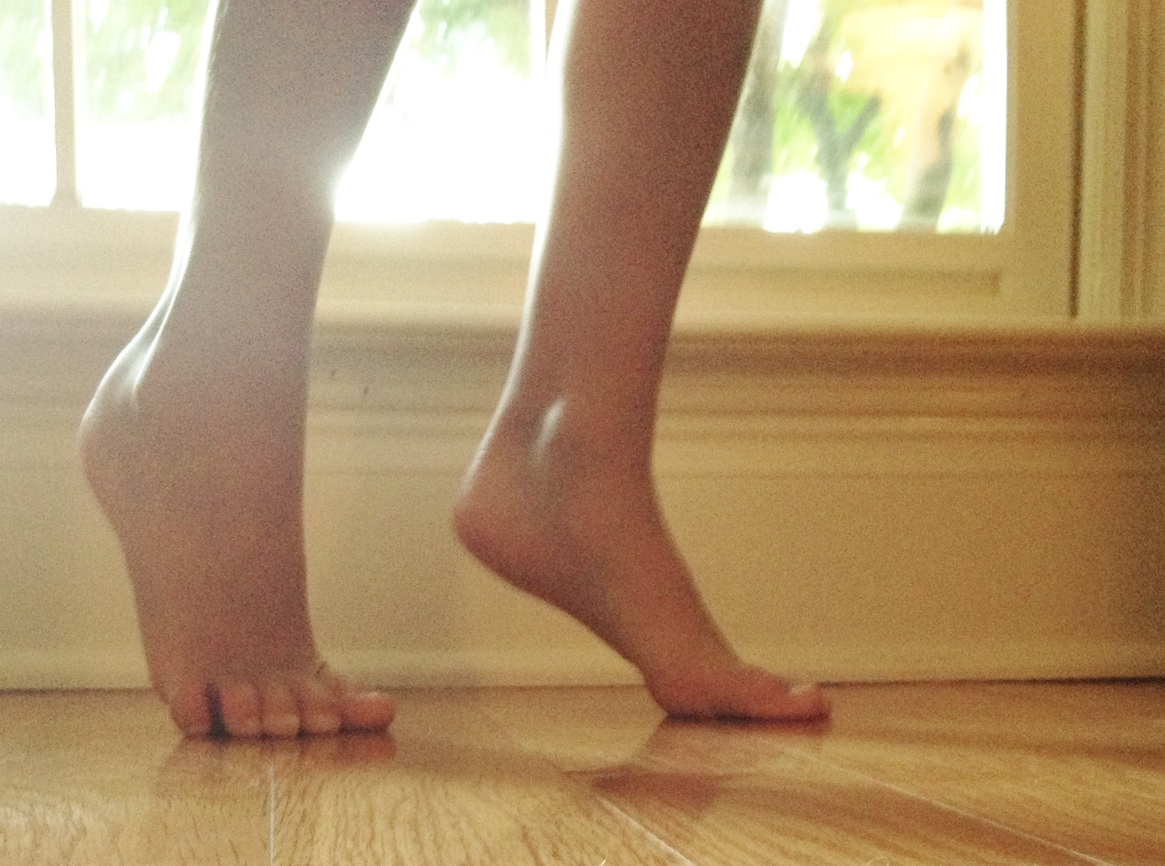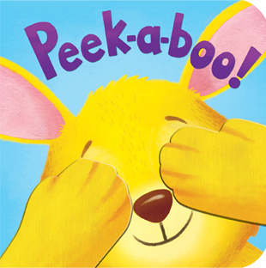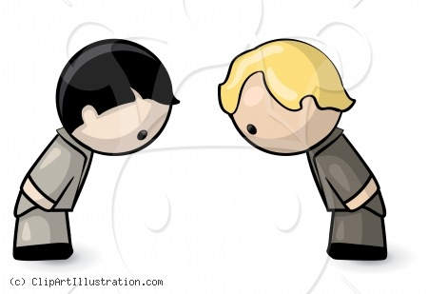

**BOW**

**PEEK-A-BOO**

**LEFT**

**RIGHT**

